CONCEPT BUSINESSPLAN


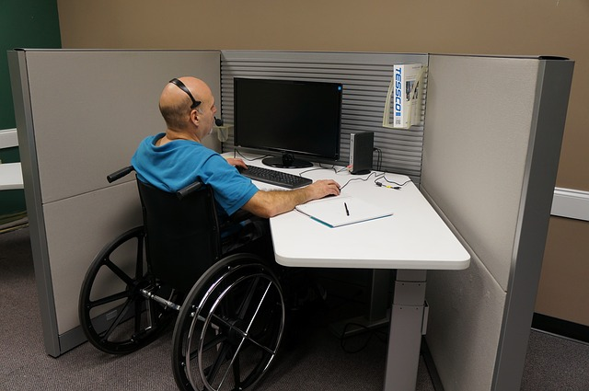
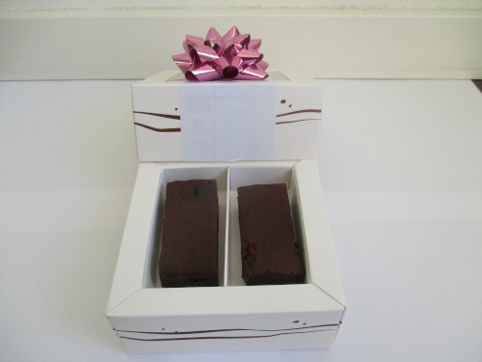
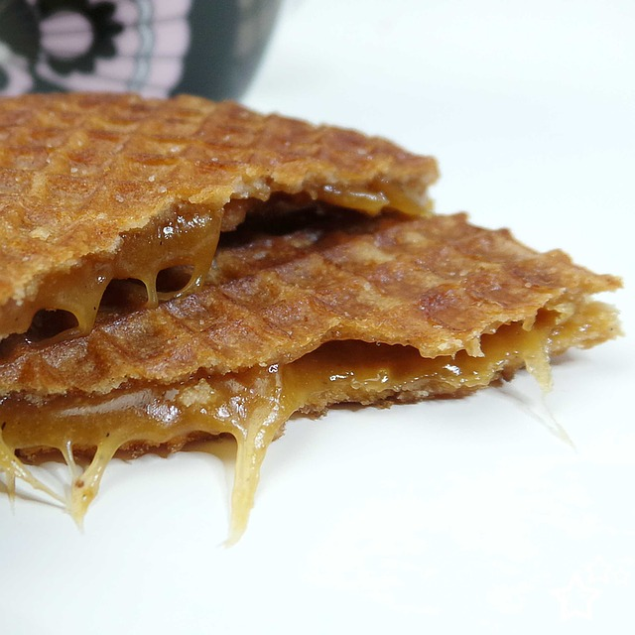
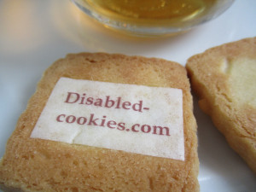
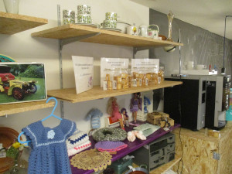

Businessplan; DisabledCookies.com

“Cookies / brownies for the good cause”

“For a better and nicer life of disabled people”

“A pilot in The Netherlands”

Organization: DisabledCookies.com / DisabledFund.org / WajongConcern.Trade
Place: Maastricht, The Netherlands
Author Ferdinand Pot
Date: October, 2023

CONTENT

Businessplan:

1 The company / organization
1.1 Business details
1.2 The product
1.3 Mission and goals
1.4 Housing
1.5 Legal form
1.6 Government
1.7 Insurances
1.8 The entrepreneur(s)

2 The market
2.1 Industry analysis
2.2 Customer analysis
2.3 Competition analysis
2.4 Supplier analysis
2.5 Distribution analysis
2.6 Environment analysis
2.7 Internal analysis
2.8 Marketingstrategy

3 Promotion
3.1 Target audiences
3.2 Corporate identity
3.3 Website
3.4 Promotion plan

4 The organization
4.1 Personnel and authorizations
4.2 Production process
4.3 Automation / computerization
4.4 Accountancy and administration

5 Finance
5.1 Sales forecast
5.2 Investment budget
5.3 Financing plan
5.4 Opening balance
5.5 Balance sheet results
5.6 Liquidity budget
5.7 Scenario analysis
5.8 Income entrepreneur(s)

6 Attachments

1 The company / organization
1.1 Business details
DisabledCookies.com / DisabledFund.org / WajongConcern.Trade
Ferdinand Pot
François de Veyestraat 8B
6221 AB Maastricht
Internet: www.disabledcookies.com
E-mail: info@disabledcookies.com
1.2 The product
The product / idea is to create a special brownie or other cookie and sell these products to retail stores/chains. In the beginning we will concentrate on retail stores / supermarkets in The Netherlands. We will start with a pilot in The Netherlands. When it will be successfull other countries / markets can be taking into account.

The special brownie or other cookies will be packaged in a special, ecological and nice packaging to offer this to the customers from the (big) retail chains in The Netherlands. The special brownie or other cookies will be sold on the brandname: “DisabledCookies.com”. A small percentage of the sold special brownie or cookies will go to the “DisabledFund.org” organization.

This organization will develop in the future projects for the disabled community worldwide to improve their lives (quality of life). This when there will be enough money to create a “registered fund”. The projects that this organization will execute will be a radio-website for disabled people, a newspaper-website for disabled people, a magazine-website for disabled people and a video-website for disabled people. More projects could be added later if there is enough money etc.

The “DisabledFund.org” organization will be something like the Dutch organization “WajongConcern.Trade”. They have their own website, which is www.wajongconcern.trade . Here you can find more information about the projects.

So the project is about selling a special brownie or other special cookie for the good cause. First we will start on the Dutch market. The internet addresses of the (big) retail chains in The Netherlands, you can find these at chapter 6 (Attachments) in this businessplan.

Also we did some small market-research in the United States about this special cookie or brownie. The insights that we did get from this small market-research are:

– 26 percent says that they buy three times a month a package of cookies or brownies.
– 19 percent says to buy a packages of cookies or brownies at a supermarket.
– 35 percent says that they would pay around two dollar for a package of cookies or brownies.

All the insights / results from this small market-research can be found in chapter 6 from this businessplan (Attachments).
Already thanks for you time to take a look at this special businessplan. Thanks again!

1.3 Mission and goals
The mission of the DisabledCookies.com organization is to collect money for the good cause projects for the DisabledFund.org organization. Projects where you can think of are a newspaper-website for disabled people, a magazine-website for disabled people, a radio-website for disabled people and a video-website for disabled people. The website “DisabledCookies.com” will link to these websites in the future. These websites will improve the lives (quality of life) of the disabled people worldwide. A small percentage (like ten percent) of the special brownies or other special cookies, goes to the DisabledFund.org organization. The other profits can goes to other good causes.

1.4 Housing
For the housing for the “DisabledCookies.com” organization which will work close with the “DisabledFund.org” organization we will look in the future for a cheap office at a multi-company building in the United Kingdom. Perhaps there will be a cheap office to rent in the London area. We choose for the United Kingdom / London area, because here the volunteers for the several websites speak and write the English language. The cost of the office rental is approximately estimated around 3.000 euro's per year. This will be paid after there is enough money fundraised for the “registered fund” for the “DisabledFund.org” organization. The rent will be paid from the registered fund earnings.

1.5 Legal form
There will be no legal form for the “DisabledFund.org” organization. All the income will come from the “registered fund”. The best way to describe the “DisabledFund.org” organization is as a private volunteer initiative. We will get a insurance at a insurance company for all the volunteers. The volunteer insurance services is estimated about 12 dollar per volunteer per year (Source: insurancequotes.com).
1.6 Government
You do not need a permit from the Dutch governement to develop a new brownie or other cookies for the Dutch market. There are some requirements from the Dutch government about packaging and labeling food products. Also there are some requirements about producing safe food products. The internet can give more information about these topics.
1.7 Insurances
We want to work with a “private label” organization, and they have already the right insurances. But we have to check this, so that we know this is for sure. There are several “private label manufacturers” in The Netherlands that can deliver brownies or other special cookies.
1.8 The entrepreneur(s)
We will look for volunteers that can make promotion for the “DisabledCookies.com” formula/concept. They must have “entrepreneurial” skills. If they have not the right skills yet, we perhaps can help them. There is a cheap e-learning platform called “Udemy.com”. This e-learning platform provide a lot of online courses about promotion/marketing/entrepreneurship. It is possible to start a online course for a cheap price from around 20,- dollar per online course. There is just one requirement to the entrepreneurs/volunteers is that they understand the English language a little bit.
2 The market
2.1 Industry analysis
Underneath you can find some points for attention regarding the industry analysis for the “DisabledCookies.com” organization:
2.1.1 Industry
The industry can be described as the “biscuits-market” in The Netherlands. We searched on the internet and found some interesting information. The volume sales for the Dutch “biscuits-market” in the year 2015 was 138.000 ton (Source: vmt.nl). In the year 2012 the Dutch “biscuits.market” had a turnover from almost 596 million euro. In the year 2013 is the growth estimated to 607,1 million euro (Source: vmt.nl).

Between the year 2007 and the year 2012 the total Dutch “biscuits-market” decreased its sales volume from 139.000 ton to 134.000 ton.

The snack manufacturer “Mondelez”, which is know for the brands “Oreo”, “TUC” and “LU” is the market leader on the Dutch biscuits-market. This with a share of 30 percent. The next one is “United Biscuits”, know from brands like “Verkade” and “Sultana”. This with a market share from 21 percent (Source: vmt.nl).

All the other companies on the biscuits-market in The Netherlands have together a market share of 42 percent. This group of companies exists out of companies like “Lotus Bakeries” (6 percent), “Pally” (5 percent) and “Bolletje” ( 4 percent) (Source: vmt.nl).
2.1.2 Attractiveness market
The “attractiveness” of the Dutch biscuit-market we can describe this market as “normal attractive”. Not very attractive and also not “not-attractive”. We made this statement because customers like more and more “healthy” and “ecological” products. But the market can be described still as attractive because the market is big and has a sales volume of million's. In the year 2012 the Dutch biscuits-market had a turnover from 597 million euro (Source: vmt.nl). That can be described as a “big” market. Private label opportunities are offered by several biscuits manufacturers in The Netherlands.
2.1.3 Total market demand
The “biscuits-market” had in the year 2012 a turnover from almost 597 million euro. The growth in the year 2013 was estimated about 607,1 million euro (Source: vmt.nl). So the total market demand is about million's for the Dutch market. With these numbers we can conclude there is enough “space” on the biscuits-market to introduce a new brownie or other cookie for the Dutch customers.
2.1.4 Cost structure
We do not have the “numbers” of the cost structure of the biscuits-market in The Netherlands. But the “DisabledCookies.com” organization would operate with a low cost structure. We want to work with volunteers. This will keep the personnel-costs very low. Also we keep an eye on spending money.
2.1.5 Market leaders
The market leader for the Dutch biscuits-market is the snack manufacturer “Mondelez”. The snack manufacturer “Mondelez” has a market share of 30 percent in The Netherlands (Source: vmt.nl). Next to this all the other comapnies on the biscuits.market in The Netherlands have together a market share of 42 percent. Like companies as “Lotus Bakeries” (6 percent), “Pally” (5 percent) and “Bolletje” (4 percent) exists this group of companies. But the biggest one, the market leader, on the Dutch biscuits-market is snack manufacturer “Mondelez” (Source: vmt.nl).

2.1.6 Ease of accession
The convenience of accession of the Dutch biscuits-market is easy. There are several “private label manufacturers” in The Netherlands. We will perhaps compare this services to make a good decision, for the right “private label manufacturer”.
2.1.7 Competition
If you take all biscuits, cookies and brownies in to account on the Dutch biscuits-market, there is a lot of competition. You only have to visit a supermarket in The Netherlands and look at the biscuits category in the store. We did some online research by two Dutch supermarkets who have their products that they sell online. For a large supermarket in The Netherlands called “Albert Heijn” we visited the website ah.nl . On this website we saw that they sell around 692 kinds of cookies (Source: ah.nl). For another large supermarket in The Netherlands called “Jumbo” we visited the website jumbo.com . At this website we found around 430 kind of cookies (Source: jumbo.com). This are large numbers, so the competition can be described as very high. But for a cookie “with a story and a good cause” there must be some space on the shelf in some retail stores.
2.1.8 Importance of the market
The importance of the biscuits-market in The Netherlands can be descibed as “important”. For this market we talk about a turnover every year in million's of euro's. The Dutch “biscuits.market” had a turnover from almost 596 million euro in the year 2012 (Source: vmt.nl).
2.1.9 Laws and rules
For the labelling and packaging for the “DisabledCookies.com” products, there are some laws/rules from the Dutch/European government. These rules concern about several topics for prepackaged food products. More information about this topic can be found at the website www.nvwa.nl . Next to this there are some laws/rules about food manufactering and hygiene. These laws/rules can also be found at the website www.nvwa.nl .

2.1.10 Changes in the market
There are some changes in the market / world. Consumers like more ecological packaging. This for the environment. Next to this biological ingredients are also prefered by consumers. This are two points to take in to account for the future.
2.1.11 Substitute products
When we talk about “substitute products” for a special brownie or other cookie, you can think of potato crisps or a granola bar. Also you can think of chocolate bar as a substitute product for a special brownie or other special cookie.
2.2 Customer analysis
Underneath you can find some points for attention regarding the customer analysis for the “DisabledCookies.com” organization:
2.2.1 Potential customers (extern and intern)
The potential customers (extern) for the “DisabledCookies.com” organization can be described in eight kinds of customers. Underneath you can find a descripiton of these (extern) potential customers for the “DisabledCookies.com” / DisabledFund.org organization:

-1- People with mobility and physical impairments

-2- People with spinal cord disability

-3- People with head / brain disability

-4- People with a vision disability

-5- People with a hearing disability

-6- People with a cognitive or learning disability

-7- People with psychological disorders

-8- People with invisible disabilities
This eight potential customer group are the target audience in The Netherlands. There were about 807.000 people in The Netherlands who are incapacitated and receive a disability insurance from the Dutch government in the year 2017 (Source: volksgezondheidenzorg.info).

-9- Volunteers (intern customers), These can be retired people or other volunteers who can help with the several websites for the DisabledFund.org organization.
2.2.2 Types of customers
Underneath you can find a description about the “types” of customers we can possible face in the future for the DisabledCookies.com concept/formula:

-1- Regular / daily customers with a disability. These people want to support the several websites of the DisabledFund.org organization. They know self what it is to live with a disability and are ready to buy a package “DisabledCookies.com” in the supermarkets in The Netherlands.
-2- Regular / daily customers without a disability. These people also want to support the DisabledFund.org organization. They do not have a disability by them self, but they found it be great to support the disabled community worldwide.
-3- Valentine customers. These people like Valentine's day and want to buy for this special occasion a (special) “DisabledCookies.com” packaging.
-4- Eastern customers. These people like Eastern and want to buy for this special occasion a (special) “DisabledCookies.com” packaging.
-5- Christmas / Holidays gift customers. These people like Christmas and the Holiday season and want to buy for this special occasion a (special) “DisabledCookies.com” packaging.
2.2.3 Group size
The group size for the “Disabled Cookies.com” / “DisabledFund.org” organization are in first sight all the people in The Netherlands older then the age of 18 years. In the year 2011 there were 13,5 million people with the age of 18 year or older (Source: startpagina.nl). We want with searchengine marketing reach a lot of these people with a nice “DisabledCookies.com” website.
2.2.4 Buying behavior
The “buying behavior” can be described as “good”. We did some market-research and on the question: “How often in one month do you buy a package of cookies or brownies?”, 28 percent of the respondents answered that they buy twice a month a package of cookies or brownies. 26 percent answered that they buy three times a month a package of cookies or brownies. And 13 percent answered they buy a package of cookies or brownies between three and six times a month.
2.2.5 Utility and image

The utility of the “DisabledCookies.com” concept/formula is that we have a source of financing for the “registered fund”. In this way the “registered fund” can grow financially. With this money we can set-up, promote and maintain the websites for a better and nicer life of disabled people worldwide. We want to set-up a online magazine for disabled people, a online newspaper-website for disabled people, a radio-website for disabled people and a television/video website for disabled people. The “registered fund” plays a important financial role in this. This to pay all the bills for the websites etc. The image that we want to establish is “thrustworthy” “helpfull” and “informative”, and maybe more in the future.
2.2.6 Moment of buying
Het moment of buying a package of special cookies or brownies are the regular opening hours of the several supermarkets in The Netherlands. This can be in the morning, afternoon or the evening. This for the “regular needs” of the several customers in The Netherlands. For the “Holidays” customers they can buy more packages of the special cookies or brownies in the supermarkets for “Holiday” gifts.
2.2.7 How does the customer buy
The customer will buy the “DisabledCookies.com” product with pleasure. Because they can support the good cause, the “DisabledFund.org” organization, which will create websites for a better and nicer life of disabled people worldwide. The customers will buy the product with pleasure by Dutch (large) supermarkets/retailers. They can buy with pleasure in the retail-store or online in the webshop when this is possible.
2.2.8 Catchment area

The catchment area for the “DisabledCookies.com” / “DisabledFund.org” organization is the country The Netherlands. Hereby we focus on people at the age of 18 or elder. In the year 2011 there were 13,15 million people in The Netherlands who fits this criteria (Source: startpagina.nl).
2.2.9 Trends
A trend is that social media and internet get more and more a important role in the society. We want to respond on this trend by creating a good website on the domain www.disabledcookies.com . Also we want to create a nice website for the “DisabledFund.org website. Next to this we will advertise the product on social media in the future.
2.3 Competition analysis
Underneath you can find some aspects about the competition analysis for the “DisabledCookies.com” concept/formula:
2.3.1 Direct competitors

There are not much direct competitors that offers unique cookies or brownies, that are direct related to a good cause. The only manufacturer we know that sells brownies/cookies for the good cause on a large scale is the famous Greyston Bakery in the United States (Source: greyston.org). The most cookies or brownies are sold for profit mainly. The “DisabledCookies.com” concept is different. We want to sell cookies or brownies for mainly the good cause (charity). The charity is the “DisabledFund.org” organization which will realize interesting websites for disabled people worldwide, so that they get a better and nicer life (quality of life).

2.3.2 Number of competitors

There are a lot of competitors for the “DisabledCookies.com” concept/formula, when you look at mainstream cookies or brownies at the shelfs of supermarkets in Holland/The Netherlands. We counted at a large supermarket in The Netherlands called “Albert Heijn” that they sell 692 kinds of cookies (Source: ah.nl). For another large retailer in Holland/The Netherlands we counted 430 kind of cookies (Source: jumbo.com). These numbers show that there is a lot of competition on the biscuits-market in The Netherlands. But we have a special asset and that is that a small percentage of the “DisabledCookies.com” concept/formula goes to a good cause/charity, the “DisabledFund.org” organization. That is our distinctiveness!

2.3.4 Pricing
The pricing for the “DisabledCookies.com” will be around 1,99 euro for one package. We did some market-research on the internet and 39 percent of the respondents say that hey would like to pay a price for this product from around one dollar. 35 percent of the respondents say that they would pay a price from around two dollar for a package of cookies or brownies. 15 percent of the respondents say that they would like to pay a price of one dollar and 50 cents for this product. So we think a price of 1,99 euro is good price for the Dutch market for one package of the “DisabledCookies.com” product.

2.3.5 Strategy competitors
We do not have information about the strategy of the competitors. So we skip this subject in this concept businessplan.
2.3.6 Plans of the competitors
We do not have information about the plans of the competitors. So we skip this topic in this concept businessplan.
2.3.7 To be better
We want to be better as a “social” cookie or brownie supplier/manufacturer / producer / private label owner. It must be a qualitive good cookie or brownie. But the “social” aspect of supporting the “DisabledFund.org” organization, which will realize websites for the disabled community, we want to be better in this.
2.3.8 Promotion competitors
The most promotion activities of competitors are offers in paper and digital promotion maps of large retailers in The Netherlands. Some competitors have their own branded website like “Milka” with information for example about the products, one of the products is also the “Milka Choco Brownies” (Source: milka.nl). We would also create a nice website about the “DisabledCookies.com” product(s).
2.3.9 Service competitors
There are a lot of competitors, so it is be difficult to research all the services provided by these competitors. But we visited one website of a possible competitor and that is the milka.nl website. The services that they provide are actions to win prizes and there is a large contact-form, for questions of customers etc. (Source: milka.nl). We also want to create a nice website in the future with contact-information, so that customers can ask questions about the product etc.
2.3.10 Motivation of personnel
We did not any research about the motivation of the personnel from competitors. There are a lot of competitors, so this is not easy to establish this in a short time. But we think we could attract good motivated volunteers for our self to create the several websites for disabled people, because they work for a good cause.
2.3.10 Market pull back
When the “DisabledCookies.com” concept/formula unexpectedly will not be successfully, we can think of a market pull back. Customers will be informed that there will be no longer “DisabledCookies” on the market. Also the volunteers will be informed correct and on a short time basis. We would thank everybody for their efforts and time. But we hope we have not to do a “market pull back”.
2.4 Supplier analysis
Underneath you can find some points related to the supplier analysis for the “DisabledCookies.com” concept/formula.
2.4.1 In the neighborhood
First we want to start with a pilot in The Netherlands. So we will not start locally but start nationwide. For the volunteers that will create the websites for the disabled people we will recruit them perhaps locally. So that they do not have a large travel time and travel costs.
2.4.2 Price / quality proportion
We want to offer a special cookie or brownie with a good price / quality proportion. The cookie or brownie ingredients must be from a good quality. Maybe in the future we will concentrate on a more and good quality environmental friendly packaging . Next to this we can think in the future about hundred percent biological ingredients for the product for a fair price from suppliers.
2.4.3 Delivery reliability
We will look for a private label manufacturer / producer with a good delivery reliability. This first for the pilot project in The Netherlands. But we will also check if the private label manufacturer has a good worldwide delivery reliability.
2.4.4 Flexibility
We want to check possible suppliers about their flexibility. The private label manufacturer must be flexible and innovatif. This for new product development for the cookies itself but also for innovatif packaging oportunities and new concepts etc.
2.4.5 Innovatif suppliers
We want to work only with innovatif suppliers / private label manufacturers. This because new ideas for new cookies concepts are important. We also will look for suppliers / private label manufacturers with modern/inovatif cookie-making-machines and modern / innovatif packaging machines.
2.5 Distribution analysis
Underneath you can find some points related to the distribution analysis for the “DisabledCookies.com” concept/formula:
The distribution of the packaged “DisabledCookies.com” cookies will be done by the private label manufacturer. This to the several (pilot) supermarkets in The Netherlands to sell the products. We will check if the private label manufacturer has the right skills, knowledge, IT infrastructure and a good fleet of trucks that can transport the cookies to the several (pilot) supermarkets in The Netherlands. Also we check if the private label manufacturer has enough knowledge about “Supply Chain Management” and “Category Management”.
2.6 Environment analysis
Underneath you can find some points related to the environment analysis for the “DisabledCookies.com” concept/formula:
2.6.1 Population structure
In the year 2017, the country, The Netherlands, counted 17 million inhabitants. In the year 2040 the inhabitants of The Netherlands will increase to 17,8 million inhabitants (Source: Centraal Bureau voor de Statistiek (CBS)). The “aging” of the society plays also a important role in The Netherlands. This we can consider. It is important to make a special cookie or brownie that the older ones also like.
2.6.2 Role government
The role of the goverment is to take care that a lot of people will participate in the society. We will work with volunteers to create and promote the several websites for disabled people. In this way we contribute to a “participation society”.
2.6.3 Economy
In the past the Ducth economy has turned badly. At this time the economy is in The Netherlands is doing well. Now it is well the fact that it is difficult to get (paid) “personnel”.
2.6.4 Technology
The DisabledCookies.com organization will create a modern website with information about the special cookies or brownies. Internet becomes more and more important in the world. Next to this customers use more and more “apps” on their smartphone. Also “social media” becomes more and more important in the world.
2.6.5 Socio-cultural factors
Social Entrepreneurship becomes more and more important in the world. The DisabledCookies.com organization can be described as a “social entrepreneurship” organization. The mission is to improve the lifes of disabled people, by creating interesting websites for the disabled community worldwide.
2.6.6 Environment
The DisabledCookies.com organization will work environmental friendly. When we will create “flyers” for the promotion of the special cookies or brownies we will use recycled paper. We want to be a sustainable organization.
2.7 Internal analysis
Underneath you can find some aspects for the “internal analysis” of the DisabledCookies.com organization:
2.7.1 Motivation
The motivation of the volunteers for the DisabledCookies.com organization will be good. The volunteers can help to make a nice “DisabledCookies.com” website and help with the other websites, like a radio-website for disabled people, a online magazine for disabled people, a video-website for disabled people and a radio-website for disabled people. This is nice work to do, because you can help the disabled community worldwide. This will give the volunteers the necessary motivation.
2.7.2 Education and experience
We will search for the right volunteers, with the right skills for the DisabledCookies.com organization. Some important skills are “entrepreneurial”, “studiously” and “teamwork”. When some of the volunteers do not have the right skills then we will educate them. For this education we will use the e-learning platform Udemy.com. You can think about online courses with several topics like “retail-management”, “online marketing” and “writing for the web” etc. It is possible to start a online course at Udemy.com for a cheap price. For example there are courses for 20 dollars per course. That is not a lot of money for a online course. When necassary we will buy some cheap courses at the Udemy.com platform. This to develop the skills of our volunteers.
2.7.3 Knowledge and market
By the DisabledCookies.com organization there is enough knowledge of the market. We did some research and also a lot of information we can found on the internet. Next to this it is possible to do some cheap e-learning courses on the Udemy.com e-learning platform. This could establish more knowledge on specific topics etc.
2.7.4 Internal organisation
The internal organisation will in the future exists of several volunteers. Hereby you can think of ten volunteers in parttime functions. You can think of the working hours from 13:00 to 17:00. The functions you can think of are web-editor, linkbuilder/online marketeer and research-assistant etc.
2.7.5 Innovative strength
The innovative strength of the DisabledCookies.com organization will be the strength to change the recipe for the cookies. We will do research regularly to optimize the recipe of the cookies. So we will in the future offer the best cookies with the best taste for our customers.
2.7.6 Good name and brand awareness
The DisabledCookies.com organization has a good name but no brand awareness. We want to advertise on the internet, so that our brand awareness will increase. You can think of advertisements on searchengines like Google or Bing. This will end in a better brand awareness for the DisabledCookies.com organization.

2.7.7 Height turnover
We expect in the first year a turnover of 298.500 euro. In the second year we expect a turnover of 348.500 euro. This with a retail-price of 1,99 euro per package of the DisabledCookies.com concept/formula. For a financial overview we refer to the financial part of this concept businessplan of the DisabledCookies.com organization.
2.7.8 Cost structure
We want to work with a low cost structure. We want to operate with a private label manufacturer and volunteers. This will support the “low cost structure” of the DisabledCookies.com organization. For more information on the low cost structure that we use we will refer to the financial part of this concept businessplan of the DisabledCookies.com organization.
2.7.9 Margin of profit
The margin of profit for the private label manufacturer will be around fifty percent. The margin of profit for the DisabledCookies.com organization will be around ten percent. For more information about the margin of profit for both organizations (the private label manufacturer and the DisabledCookies.com organization) we will refer to the financial part of this concept businessplan of the DisabledCookies.com organization.
2.7.10 Quality of product or service
We want to create a special cookie or brownie with high quality ingredients. It is important that we deliver constant high quality cookies or brownies. When the quality is good, customers will buy again and again a package of the DisabledCookies.com concept.
2.7.11 Quality of the production
We will select a good private label manufacturer with production lines that meets high quality standards for the production of the special cookies or brownies. Quality is very important, so that customers will buy again and again the DisabledCookies.com packages.
2.7.12 Flexibility of the company
We want to operate as a flexible company/organization. For example, when customers want a new cookie or brownie. We will work to make this happen. We want to operate as a flexible organization that adapt new market circumstances.
2.7.13 Investment space
There is not a lot of investment space for the DisabledCookies.com organization. But this is not necessary, because we want to work with a private label manufacturer. So we do not have to invest in a cookie factory.
2.8 Marketingstrategy
2.8.1 SWOT-analysis and Confrontationmatrix
Underneath you can find the SWOT-analysis and Confrontationmatrix for the DisabledCookies.com organization:
2.8.1.1 SWOT-analysis
Underneath you can find the SWOT-analysis for the DisabledCookies.com organization:
STRENGTHS (Strengths / Internal):  -Nice website for the DisabledCookies.com website.  -Nice Domainname; www.disabledcookies.com  -Quality cookies or brownies for the customers.  -Supporting the “Disabled Community” with several interesting websites (radio-website, video-website, online magazine-website, online-newspaper-website) | WEAKNESSES (Weaknesses / Internal):  -There is not yet a good volunteer-organization.  -There is no good working team at this time.
OPPORTUNITIES (Opportunities / External):  -Biological ingredients become more populair. We can perhaps make cookies in the future with 100 percent biological ingredients. | THREATS (Threats / External):  -Perhaps more competitors in the future.
2.8.1.2 De Confrontationmatrix
Underneath you can find the modelled Confrontationmatrix for the DisabledCookies.com organization:
GROWTH:  -SO-strategies (Strenghts-Opportunities strategy)  -Strategy for the DisabledCookies.com organization. | STRONGEN WEAKNESSES:  WO-strategieën (Weaknesses-Opportunities strategy)
DEFENSE:  -ST-strategies (Strenght-Threats strategy) | PULL BACK OR BEND OVER:  -WT-strategies (Weaknesses-Threats strategy)
The DisabledCookies.com organization will follow the “SO-strategy” (Strenghts-Opportunities strategy) to grow. We want to improve our brand name (DisabledCookies.com), through advertising on searchengines like Google and Bing. Perhaps we will also place advertisement on the website marktplaats.nl . This all to improve our brand name (DisabledCookies.com).
2.8.2 The Marketingmix

Underneath you can find several aspects from the marketingmix for the DisabledCookies.com organization:
2.8.3 Product
The product is a special cookie or brownie that is made by a private label manufacturer. A small percentage of the retail-price goes to the DisabledFund.org organization (registerd fund). We think of a registered fund by the “KansFonds” organization in The Netherlands. With the revenue of this registered fund we will create a radio-website for disabled people, a online magazine for disabled people, a video-website for disabled people and a online newspaper for disabled people. We want to create this because we want to improve the lifes of disabled people. We want to serve the disabled community worldwide in the English language with these websites.
2.8.4 Place
A package of the DisabledCookies.com concept must be available in the most large supermarkets in The Netherlands. You can think of supermarkets like; “Albert Heijn”, “Jumbo”, “Plus”, “Aldi” and “Lidl” etc. It is important that by many supermarkets the product is on the shelf, so that it is easy available for customers.
2.8.5 Price
The pricing of one package of DisabledCookies.com concept will be 1,99 euro. 35 percent of the respondents of the market survey say that they would pay around two dollar for a package of cookies or brownies. We think this is a reasonable price for a cookie or brownie with a good cause in mind.
2.8.6 Promotion
For the promotion of the DisbaledCookies.com concept we will create advertisements on the internet. You can think of advertisements on searchengine Google or searchengine Bing. Next to this we will create “flyers” and spread them amongst people in The Netherlands.
2.8.7 Personnel
The personnel/volunteers of the DisabledCookies.com organization will be highly motived to make a success of the “DisabledCookies.com” concept/formula. A small percentage of the sold “DisabledCookies.com” will go to the good cause: “DisabledFund.org” organization which will be a registered fund for a nicer and better life of disabled people. They will serve the disabled community worldwide. This all with a online magazine-website for disabled people, a radio-website for disabled people, a video-website for disabled people and a online newspaper for disabled people. So the personnel/volunteers of the “DisabledCookies.com” organization will be highly motivated to contribute to this good cause.
2.8.8 Product markt combination
The product markt combination are the inhabitants of The Netherlands from 18 years old or older, that want to buy biscuits/cookies in Dutch supermarkets and want to support the good cause. A small percentage of the sold cookies or brownies will go to the “DisabledFund.org” organization, which is a registerd fund and they are the “financial engine” to create several interesting websites for the disabled community worldwide.

3 Promotion
Underneath you can find some aspects about the “promotion” for the DisabledCookies.com organization:
3.1 Target audiences
The target audience for the DisabledCookies.com concept are for the pilot the inhabitants of The Netherlands from 18 year old or older, who want to support the good cause by buying a package of the “DisabledCookies.com” concept/formula.
3.2 Corporate identity
We want to use the corporate identity that is now already used at the DisabledCookies.com website. See for more information: http://www.disabledcookies.com .
3.3 Website
For a small part the DisabledCookies.com website already exists. In the future we want to expand this more and want to embellish this more. This will result in the future in a nice and good website.
3.4 Promotion plan
We want to promote the “DisabledCookies.com” in several ways in the future. We want in to the future advertise on searchengine Google and searchengine Bing to expand our brand name. Next to this we want perhaps place advertisements on the website “marktplaats.nl”. And we also want to create a “flyer” and spread them amongst people in The Netherlands. We will made the “flyer” very attractive with nice photo's of the cookies and information about the good cause.

4 The organization
Underneath you can find some aspects about the “organization” for the “DisabledCookies.com “ organization:
4.1 Personnel and authorizations
To create a voluntering organization for the “DisabledCookies.com” concept/formula we will write vacancies and job profiles. This to recruit the right volunteers. We think of several jobs like; web-editor volunteer and marketing employee/volunteer etc. The authorizations will be worked out on paper, so that for everyone there authorizations and responsibility is clear.
4.2 Production process
The production process is to create special recipes for a worldwide successfull cookie or brownie. Then this successfull recipe we will send to the private label manufacturer, so that they can make and package the special cookies or brownies on a large scale. We will not build our own cookies-factory.
4.3 Automation / computerization
The “DisabledCookies.com” organization has a nice and modern website. With this nice website we present ourselves to the world. For the office automation and computerizationwe will use “open-source” software. This is good software for free. So we can work on the low-cost structure of the organization. We think of open-source software like “Open-Office”, “GIMP” and “Scribus”.
4.4 Accountancy and administration
The accountancy and administration will be done by a specialized volunteer. We will make a job profile for this important volunteer vacancy. And we will try to recruit the right person for this position.

5 Finance
Underneath you can find some charts for the financial part of this concept businessplan for the “DisabledCookies.com” organization:
5.1 Sales forecast
Underneath you can find one chart for the sales forecast for year one and year two for the “private label manufacturer” where we will cooperate within in the future:
Sales forecast in euro's | Year 1 | Year 2
Total turnover (VAT included) | 298500 euro | 348250 euro
The first year we expect a turnover from 298500 euro (VAT included). The second year we expect a turnover from 348250 euro. In year 1 we expect to sell 150000 packages for the retail-price of 1,99 euro (turnover 298500 euro, VAT included). In year 2 we expect to sell 175000 packages also for the retail-price of 1,99 euro (turnover 348250 euro, VAT included).

The “DisabledCookies.com” organization will get 12 percent of the turnover of the sold cookie packages. For year 1 this will be 18000 euro (VAT included) and for year 2 this will be 21000 euro (VAT includede). The amounts of money will go to the registered fund which is called the “DisabledFund.org” organization. You can also find this information in the chart below:
Percentage of turnover in euro's | Year 1 | Year 2
12 percent of turnover for the DisabledFund.org organization / DisabledCookies.com organization | 18000 euro (VAT not relinquished) | 21000 euro (VAT not relinquished)

5.2 Investment budget
Underneath you can find the “investment budget” for the “DisabledCookies.com” organization:
Investment budget in euro's | Amount | Total
Durable assets
Inventory | 1000
Others | 1000
 |  | 2000
Current assets
Liquid assets | 1000
 |  | 3000
Total investments |  | 3000

5.3 Financing plan
Underneath you can find the “financing plan” for the “DisabledCookies.com” organization after some time:
Financing plan in euro's |  | Total
Equity (among other things)
Savings | 5
 |  | 5
Debt (among other things)
Money from the registered fund (DisabledFund.org) | 10000 | 10000
 |  | 10000
Total required capital |  | 10005

5.4 Opening balance
Underneath you can find the “opening balance” for the “DisabledCookies.com” organization after some time:
Opening balance in euro's
Durable assets |  | Equity
Inventory | 1000 | Savings | 5
 |  | Input assets | 0
 |  | Subordinated loan | 0
Others | 1000
Current assets |  | Debt capital
Stocks | 0 | Long-term loan | 0
Liquid assets | 1000 | Money from the registered fund (DisabledFund.org) | 10000
Other | 7005
TOTAL: | 10005 |  | 10005
5.5 Balance sheet results
Underneath you can find the “balance sheet results” for the “DisabledCookies.com” organization:
Results budget in euro's | Year 1 | Year 2
Gross profit
Revenue | 5000 | 5500
Purchasing costs | 0 | 0
Gross profit (A) | 5000 | 5500
Costs
Personnel costs | 0 | 0
Gas, water, electricity | 0 | 0
Administration costs | 0 | 0
Business insurance | 0 | 0
Advertising costs | 1000 | 1000
Housing costs | 2500 | 2500
Other costs | 100 | 100
Depreciation investments | 100 | 100
Total costs (B) | 3700 | 3700
Operating result (A – B) | 1300 | 1800
Financing costs (interest) | 0 | 0
Net profit before taxes | 1300 | 1800

5.6 Liquidity budget
Underneath you can find the “liquidity budget” for the “DisabledCookies.com” organization:
Liquidity budget in euro's | Month 1 | Month 2 | Month 3 | Month 4
Liquid assets start month (A) | 100 | 100 | 100 | 100
Receipts
Cash sales (donations) | 500 | 500 | 500 | 500
Total receipts (B) | 500 | 500 | 500 | 500
Payments
Payments to creditors (VAT included and housing costs) | 250 | 250 | 250 | 250
Personnel costs | 0 | 0 | 0 | 0
Interest charges | 0 | 0 | 0 | 0
Repayments | 0 | 0 | 0 | 0
Private records | 0 | 0 | 0 | 0
Other expenses | 0 | 0 | 0 | 0
Total payments (C) | 250 | 250 | 250 | 250
Liquide assets (end of month) (= A + B – C) | 350 | 350 | 350 | 350
5.7 Scenario analyzes
In the future it is possible to make more scenario analyzes for the “DisabledCookies.com” organization.
5.8 Income entrepreneur(s)
The income(s) of the entrepreneur(s) and initiator(s) can perhaps be added later to this concept businessplan.
Thanks for your time to study this concept businessplan!
6 Attachments
There are five attachments enclosed by this concept businessplan. They are:

6.1 Example of packaging design “DisabledCookies.com”.
6.2 Results online survey “DisabledCookies.com”.
6.3 Internet addresses (large) retailers in The Netherlands.
6.4 Questionnaire in English language
6.5 Questionnaire in Dutch language
6.1 Example of packaging design “DisabledCookies.com”

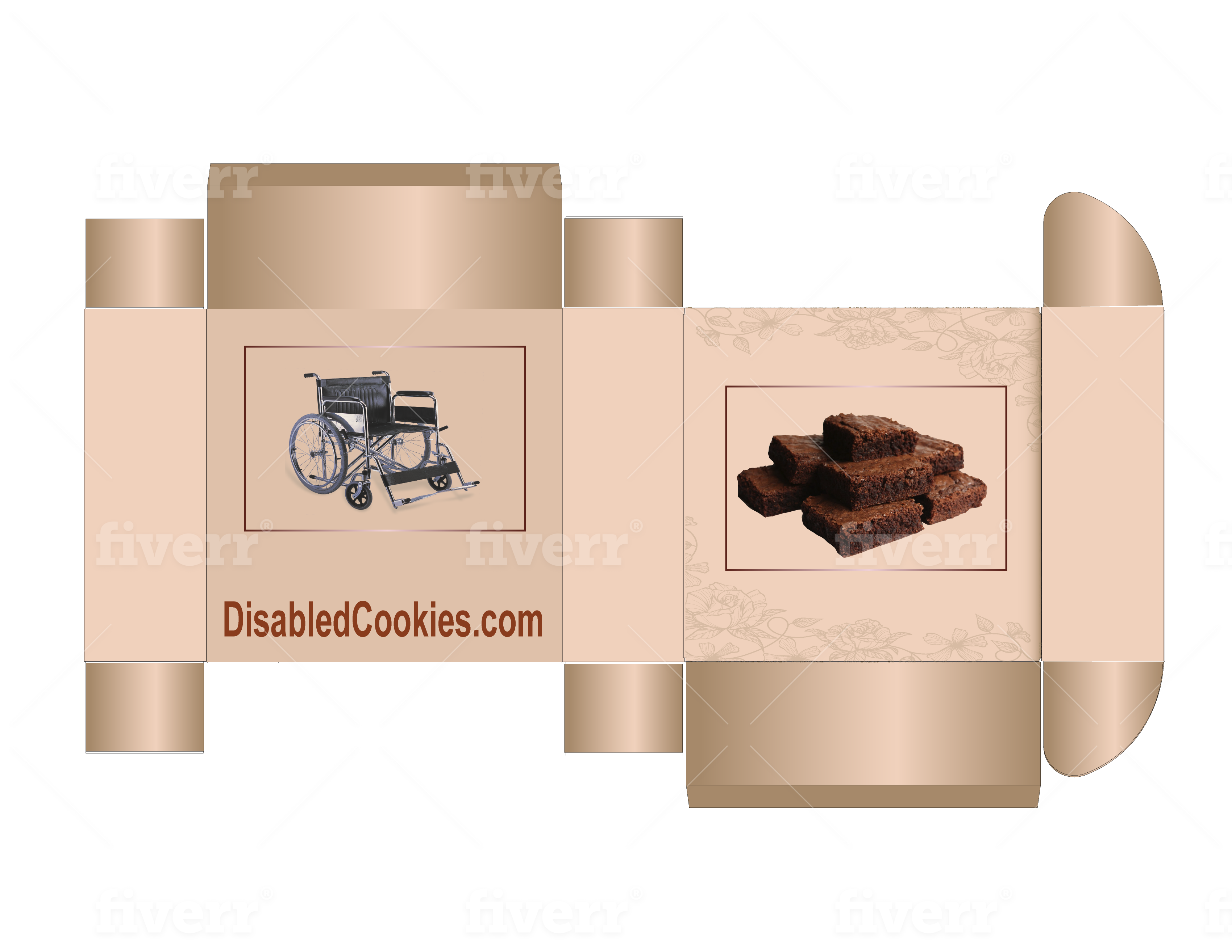
6.2 Results online survey “DisabledCookies.com”.
Results online survey “DisabledCookies.com” (December, 2019)

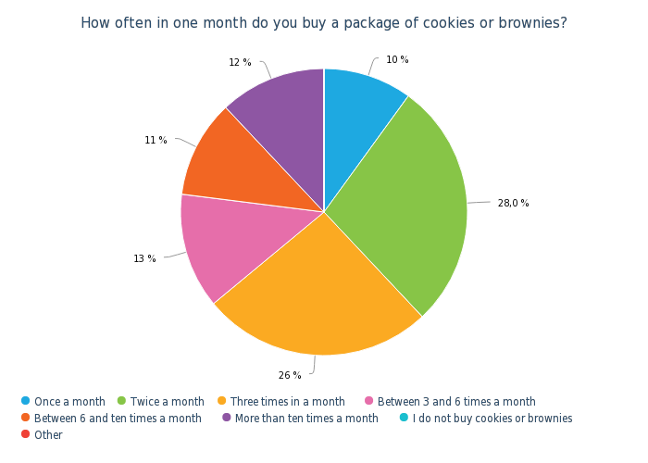

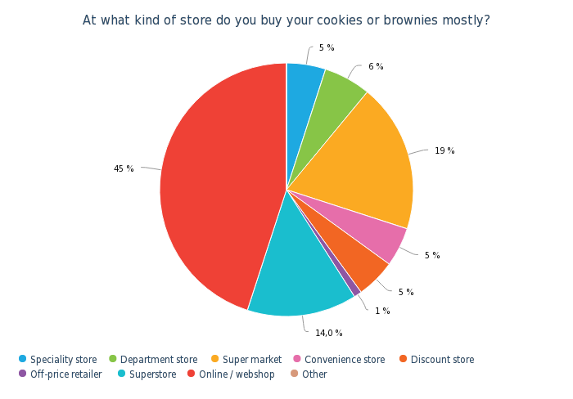

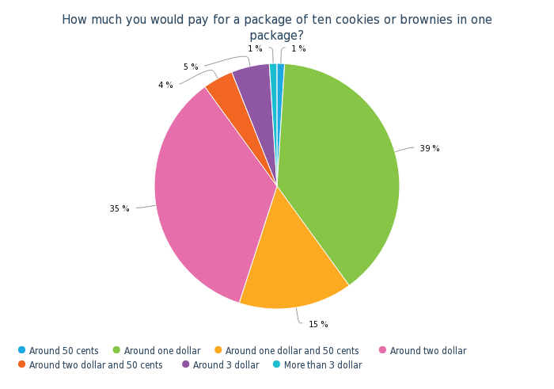

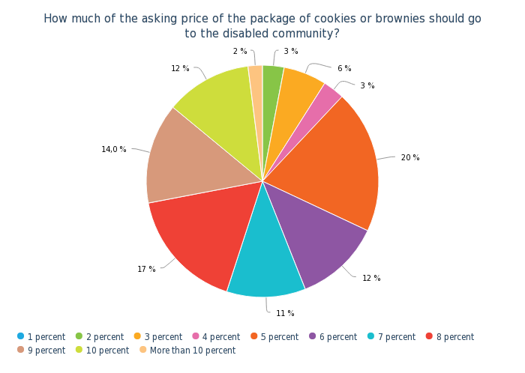

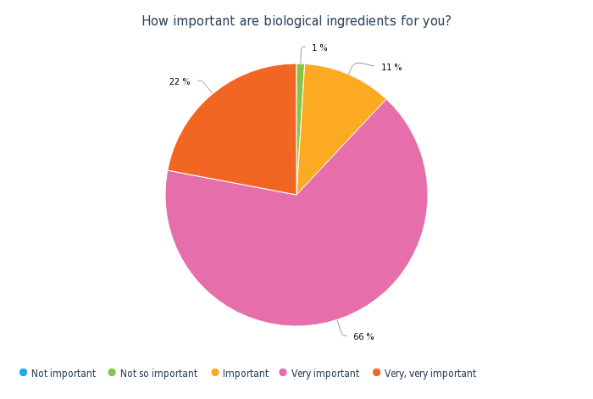

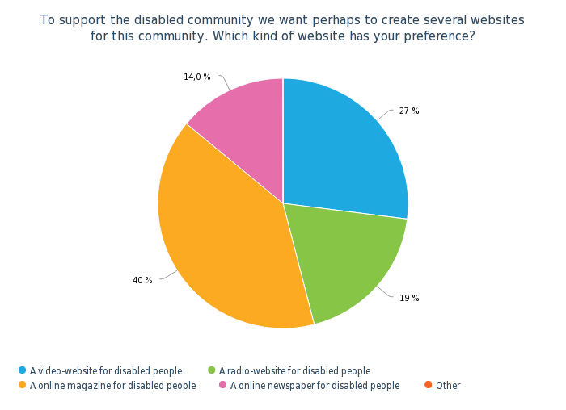

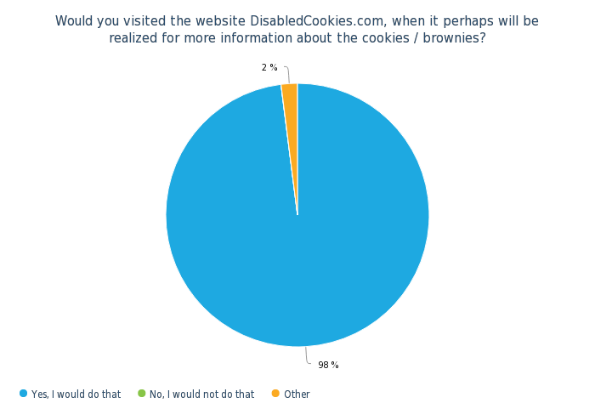
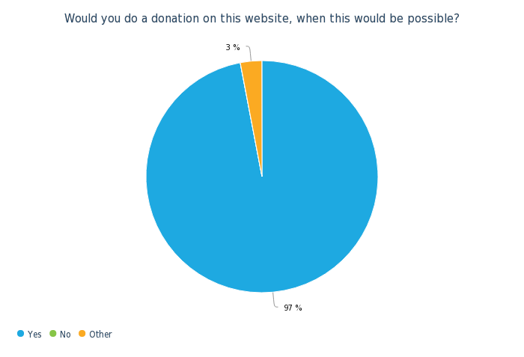

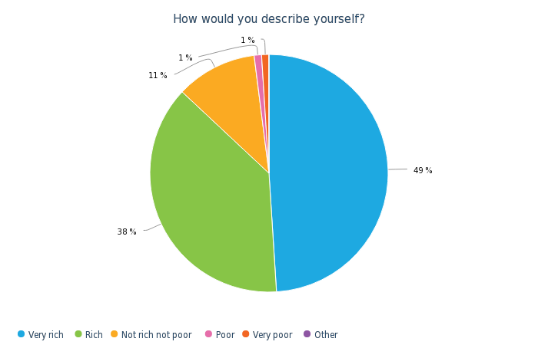
6.3 Internet addresses (large) retailers in The Netherlands
RETAILER / SUPERMARKET: | INTERNET ADDRESS:
Action | www.action.com
Albert Heijn | www.ah.nl
Aldi BV | www.aldi.nl
Boni Supermarkten | www.bonisupermarkt.nl
Coop | www.coop.nl
Deen supermarkten | www.deen.nl
DekaMarkt | www.dekamarkt.nl
Dirk | www.dirk.nl
Hoogvliet | www.hoogvliet.com
Jan Linders | www.janlinders.nl
Jumbo Supermarkten | www.jumbo.com
Lidl | www.lidl.nl
MCD Supermarkten | www.mcd-supermarkt.nl
Nettorama | www.nettorama.nl
Spar Nederland | www.spar.nl
Vomar Voordeelmarkt BV | www.vomar.nl
(Source: supermarkt.startpagina.nl)
6.4 Questionnaire in English language:
PRODUCT QUESTIONNAIRE

Name or nickname: …
Date: …

Welcome to a special questionnaire about a special made cookie. We want to know how much you appreciate this cookie. Taste the cookie (sample) en take your time to create your opinion about the cookie. Thank you for particpating in this product questionnaire!

QUESTION 1:

Everything considered, how much do you “like” or “dislike” this cookie overall?

( ) I like the cookie extremely
( ) I like the cookie very much
( ) I like the cookie moderatley
( ) I like the cookie slightly
( ) Neither like the cookie nor dislike the cookie
( ) I dislike the cookie slightly
( ) I dislike the cookie moderatley
( ) I dislike the cookie very much
( ) I dislike the cookie extremely

QUESTION 2:

In the case you liked something about the cookie, what did you like about the cookie?
(describe in words)

… … …
… … …

QUESTION 3:
In the case you disliked something about the cookie, what did you disliked about the cookie? (describe in words)
… … …
… … …

QUESTION 4:

What is your opinion about how the cookie looks like?

( ) I like the appearance of the cookie extremely
( ) I like the appearance of the cookie very much
( ) I like the appearance of the cookie moderatley
( ) I like the appearance of the cookie slightly
( ) Neither like the appearance of the cookie nor dislike the appearance of the cookie
( ) I dislike the appearance of the cookie slightly
( ) I dislike the appearance of the cookie moderatley
( ) I dislike the appearance of the cookie very much
( ) I dislike the appearance of the cookie extremely

QUESTION 5:

How would you describe the color of the cookie?

( ) The color of the cookie is much too light
( ) The color of the cookie is somewhat too light
( ) The color of the cookie is just about right
( ) The color of the cookie is somewhat too dark
( ) The color of the cookie is much too dark
QUESTION 6:

How much do you like the “texture” of the cookie?

( ) I like the texture of the cookie extremely
( ) I like the texture of the cookie very much
( ) I like the texture of the cookie moderatley
( ) I like the texture of the cookie slightly
( ) Neither like the texture of the cookie nor dislike the texture of the cookie
( ) I dislike the texture of the cookie slightly
( ) I dislike the texture of the cookie moderatley
( ) I dislike the texture of the cookie very much
( ) I dislike the texture of the cookie extremely

QUESTION 7:

How would you describe the softness/firmness of the cookie?

( ) The cookie is much too soft
( ) The cookie somewhat too soft
( ) The cookie is just about right
( ) The cookie is somewhat too firm
( ) The cookie is much too firm

QUESTION 8:

What do you found of the stickiness of the cookie?

( ) The cookie is not at all sticky
( ) The cookie is slightly sticky
( ) The cookie is moderately sticky
( ) The cookie is very sticky
( ) The cookie is extremely sticky
QUESTION 9:

What is your opinion about the moistness/dryness of the cookie?

( ) The cookie is much too moist
( ) The cookie is somewhat too moist
( ) The cookie is just about right
( ) The cookie is somewhat too dry
( ) The cookie is much too dry

QUESTION 10:

What is your opinion about the overall flavor/taste of the cookie?

( ) I like the overall flavor/taste of the cookie extremely
( ) I like the overall flavor/taste of the cookie very much
( ) I like the overall flavor/taste of the cookie moderatley
( ) I like the overall flavor/taste of the cookie slightly
( ) Neither like the overall flavor/taste of the cookie nor dislike the overall flavor/taste of the cookie
( ) I dislike the overall flavor/taste of the cookie slightly
( ) I dislike the overall flavor/taste of the cookie moderatley
( ) I dislike the overall flavor/taste of the cookie very much
( ) I dislike the overall flavor/taste of the cookie extremely

QUESTION 11:

What is you opinion about the overall saltiness of this cookie?

( ) The cookie is not at all salty enough
( ) The cookie is quite salty enough
( ) The cookie is just about right
( ) The cookie is somewhat too salty
( ) The cookie is much too salty

QUESTION 12:

Did you experience a aftertaste of the cookie?

( ) Yes
( ) No
QUESTION 13:

How did you found the aftertaste of the cookie?

( ) I found it pleasant
( ) I found it unpleasant
( ) Not applicable

QUESTION 14:

How would you describe the strength of aftertaste of the cookie?

( ) It was very pleasant
( ) It was somewhat pleasant
( ) It was neither pleasant or unpleasant
( ) It was somewhat unpleasant
( ) It was very unpleasant
( ) Not applicable

QUESTION 15:

What kind of “report mark” will you give to this cookie? Hereby is the report mark 1 extremely bad and the report mark 10 extremely good.

( ) Report mark 1
( ) Report mark 2
( ) Report mark 3
( ) Report mark 4
( ) Report mark 5
( ) Report mark 6
( ) Report mark 7
( ) Report mark 8
( ) Report mark 9
( ) Report mark 10

– End of questionnaire -

Thanks for your time to fill in the questionnaire!

(Source: partly, Sensory Evaluation of Food, Springer, 2010)
6.5 Questionnaire in Dutch language:
PRODUCT VRAGENLIJST

Naam of nickname: …
Datum: …

Voor je ligt een vragenlijst over speciaal gemaakte koekjes. Wij willen graag van je weten wat je vindt van dit koekje. Proef de koekjes (monster) uitgebreid en neem de tijd om een mening te vormen. We willen je alvast ontzettend bedanken voor je deelname.

VRAAG 1:

Alles meegenomen, hoe waardeer je dit koekje?

( ) Waardeer het koekje extreem goed
( ) Waardeer het koekje erg goed
( ) Waardeer het koekje matig goed
( ) Waardeer het koekje licht goed
( ) Waardeer het koekje niet goed maar ook niet slecht
( ) Waardeer het koekje een beetje slecht
( ) Waardeer het koekje matig slecht
( ) Waardeer het koekje erg veel slecht
( ) Waardeer het koekje extreem slecht

VRAAG 2:

In het geval dat je iets lekker vond aan het koekje, wat vond je dan lekker aan het koekje?
(beschrijf in woorden)

… … …
… … …

VRAAG 3:
In het geval dat je iets niet lekker vond aan het koekje, wat vond je dan niet lekker aan het koekje? (beschrijf in woorden)
… … …
… … …

VRAAG 4:

Hoe vindt je het koekje er in het geheel uitzien?

( ) Vond het koekje er extreem goed uitzien
( ) Vond het koekje er goed uitzien
( ) Vond het koekje er matig goed uitzien
( ) Vond het koekje er een beetje goed uitzien
( ) Vond het koekje er niet goed uitzien maar ook niet slecht
( ) Vond het koekje er licht slecht er uitzien
( ) Vond het koekje er matig slecht uitzien
( ) Vond het koekje er erg slecht uitzien
( ) Vond het koekje er extreem slecht uitzien

VRAAG 5:

Hoe zou je de kleur van het koekje omschrijven?

( ) Veel te licht
( ) Een beetje te licht
( ) Ziet er precies goed uit
( ) Een beetje te donker
( ) Veel te donker
VRAAG 6:

In hoeverre waardeer je de “structuur” van het koekje?

( ) Vond de structuur van het koekje extreem goed
( ) Vond de structuur van het koekje erg goed
( ) Vond de structuur van het koekje matig goed
( ) Vond de structuur van het koekje licht goed
( ) Vond de structuur van het koekje niet goed maar ook niet slecht
( ) Vond de structuur van het koekje licht slecht
( ) Vond de structuur van het koekje matig slecht
( ) Vond de structuur van het koekje erg slecht
( ) Vond de structuur van het koekje extreem slecht

VRAAG 7:

Hoe zou je de zachtheid/stevigheid van het koekje omschrijven?

( ) Veel te zacht
( ) Een beetje te zacht
( ) Precies goed
( ) Een beetje te stevig
( ) Veel te stevig

VRAAG 8:

Hoe vind je de “kleverigheid” van het koekje?

( ) Niet te kleverig
( ) Licht kleverig
( ) Matige kleverigheid
( ) Behoorlijk kleverig
( ) Extreem kleverig
VRAAG 9:

Wat vind je van de vochtigheid/droogheid van het koekje?

( ) Veel te vochtig
( ) Een beetje te vochtig
( ) Precies goed
( ) Een beetje te droog
( ) Veel te droog

VRAAG 10:

Wat vind je van de gehele smaak van het koekje?

( ) Vindt het extreem lekker
( ) Vindt het erg lekker
( ) Vindt het matig lekker
( ) Vindt het licht lekker
( ) Vindt het niet lekker maar ook niet niet lekker
( ) Vindt het licht niet lekker
( ) Vindt het matig niet lekker
( ) Vindt het erg veel niet lekker
( ) Vindt het extreem niet lekker

VRAAG 11:

Wat vind je van de zoutheid van dit koekje?

( ) Niet zout genoeg
( ) Een beetje niet zout genoeg
( ) Precies zout genoeg
( ) Een beetje te zout
( ) Veel te zout

VRAAG 12:

Heb je een nasmaak ervaren van het koekje?

( ) Ja
( ) Nee
VRAAG 13:

Hoe vond je de nasmaak van het koekje indien van toepassing?

( ) Plezierig
( ) Onplezierig
( ) Niet van toepassing

VRAAG 14:

Hoe zou je de sterkte van de nasmaak omschrijven?

( ) Erg plezierig
( ) Een beetje plezierig
( ) Niet plezierig maar ook niet onplezierig
( ) Een beetje onplezierig
( ) Erg onplezierig
( ) Niet van toepassing

VRAAG 15:

Welk rapportcijfer zou je dit koekje willen geven? Waarbij het cijfer 1 heel erg slecht is en het cijfer 10 heel erg goed is.

( ) Rapportcijfer 1
( ) Rapportcijfer 2
( ) Rapportcijfer 3
( ) Rapportcijfer 4
( ) Rapportcijfer 5
( ) Rapportcijfer 6
( ) Rapportcijfer 7
( ) Rapportcijfer 8
( ) Rapportcijfer 9
( ) Rapportcijfer 10

– Einde vragenlijst -

Bedankt voor je deelname aan de vragenlijst!

(Source: partly, Sensory Evaluation of Food, Springer, 2010)

